Surname and Initials:  ……………………………………………………  Reyneke,R | Session Day:  Wed,24 March  ……………… | Group no  …………  G01
Student number: 21495034


DEPARTMENT OF PHYSICS
FSK 116

GRA 1
Graphs
Introduction
The quantitative information collected during an experiment is known as data. The data is used to determine if a functional relationship between the variables in an experiment exists or not. This functional relationship can be represented in at least three ways (see section 1.2, Chapter 1 of your textbook:
a. a table of numbers
b. an equation
c. a graphical representation
The following section describes the important rules and techniques for representing data graphically.

The use of graphs
1. A graph is a visual representation of the functional relationship between two or more variables. We will limit ourselves to two variables.
2. Graphs may enable one to determine the mathematical relationship between the variables. This
mathematical relationship is called an empirical relationship. If the theoretical relationship between the variables is also known then some relevant constants can be determined by comparing the theoretical and empirical equations - for example in graph C you will determine the decay constant, λ of some decaying process.
3. Graphs can show systematic deviations of the data from the general trend of the graph.
4. Graphs make it possible to see where small changes in the independent variable cause large
changes in the dependent variable.
5. Interpolations and extrapolations can easily be made on linear graphs - for example in graph A in this practical, you will determine the resistance of the wire at temperatures other than those in the data.

Rules for drawing graphs
Rules for the drawing of graphs are summarised in the introductory section of the lab manual (p10 – 12). These rules should always be applied to all graphs that you draw.

1. Straight line graphs
If a variable y is directly proportional to another variable x, i.e., y ∝ x or y = mx, the graph is a straight line which always passes through the origin (see figure 1). In the above equation, m is called the proportionality constant, and it is the gradient of the graph.
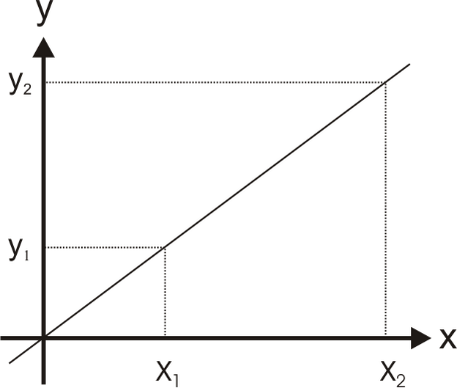
The gradient or slope of the graph is given by:
Figure 1: A directly proportional relationship.
$$m= \frac{∆y}{∆x}= \frac{y_{2}- y_{1}}{x_{2}- x_{1}}$$

Remember to calculate both Δy and Δx according to the scales and the units of the relevant axes.

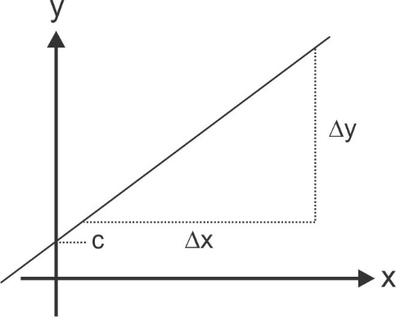
If the change in y is directly proportional to the change in x, then: Δy ∝ Δx as in figure 1.
Figure 2: A linear graph with a positive gradient
If the graph is a straight line that does not pass through the origin, like in figure 2, we still say that there is a linear relationship between the variables. The graph can be represented by the equation:
$$y=mx+c$$
where c is called the intercept of the graph on the vertical, y, or dependent axis.
The gradient m is, as previously
$$m= \frac{∆y}{∆x}= \frac{y_{2}- y_{1}}{x_{2}- x_{1}}$$

Graph A
The resistance R of a homogeneous wire has been measured at different temperatures, T. The results are shown in Table 1.
Table 1 The resistance of a wire at various temperatures
Temperature, T (ºC) | Resistance, R (Ω)
-20.0 | 307
10.0 | 325
30.0 | 338
45.0 | 353
65.0 | 362
75.0 | 375
90.0 | 382

1. Draw a graph of the resistance, R, of the wire as a function of its temperature, T, that is R(T). The temperature axis should include zero ºC, but for the sake of convenience, the start of the resistance scale should not be zero. Insert your graph on the next page.

Now that you have drawn a graph of the data and found that there is a linear relationship between the variables, you can formulate the mathematical relationship between the variables. This mathematical formula is called the empirical relationship since it was determined using experimental data.

2. Determine and clearly indicate on your graph, the change in resistance per unit change in the temperature, that is ΔR/ΔT, or the slope of the graph. Choose points 1 and 2 as far as possible from each other - see figure 1 - and do not use data points from the table. Do not forget the units of the gradient when you state its value.

3. Set up the empirical equation for the resistance of the wire at different temperatures, i.e., the formula relating the relationship between the resistance and temperature of the wire. This equation should have values and units for both constants in the linear equation. Use the symbols R and T for the variables in the equation.

4. Now that you have determined the relationship between the measured quantities, you can either use the graph or the empirical equation to determine values for the resistance of the wire at other temperatures. Let’s use the graph to determine the resistance of the wire at some temperature. You should indicate on the graph where the readings were taken:
- The resistance of the wire at -30 °C. You are extrapolating in this case. That is, you are assuming that the functional relationship between the variables will remain linear outside of the measured range. Such an assumption is risky since you do not know whether the relationship is still linear outside of the measured range of values.
- The resistance of the wire at 25 °C. Now you are interpolating, or predicting that the resistance will take on this value, a much safer bet since this is within the measured range of values.

2. The power function: y = kx^{n}
The power function is often found in physics, for example:
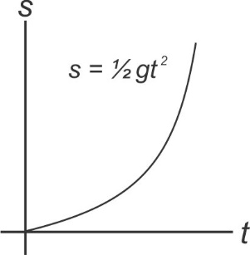
Figure 3: Freefall out of rest
- The distance, s, that an object, initially at rest, moves under the influence of gravity during a time interval t is given by:
$$s= ½ gt^{2}$$
- The period, T, of a simple pendulum depends on its length, L, according to:
$$T=k\sqrt{L}$$
- The force, F, between two point charges or masses separated by a distance, r, is given by an inverse square law:
$$F=k\frac{1}{r^{2}}$$

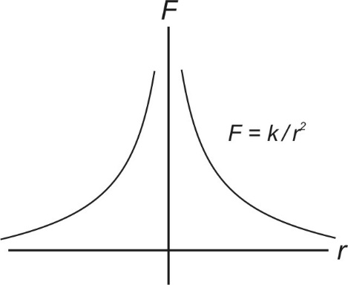
Figure 4: The electric force between two point charges

Advantages of linear representations
a. It is easy to fit data points to a straight line.
b. The formula which describes the relationship between the variables can be more easily established.
c. Interpolation and extrapolation - determining values for the dependant variable other than in the measurement set - can easily be made on a straight-line graph compared to on a curve.
It is therefore desirable be able to transform a power relationship graph into a straight line, which will be discussed next.

Transforming power relationships to straight line graphs
Starting with the general power relationship:
$$u=kv^{n}$$
Taking the logarithm on both sides:
$$\log{u}= \log{(kv^{n})}$$
$$\log{u}= \log{k}+n\log{v} ⋯(1)$$
$$Y = C+MX$$
We obtain a linear relationship between the logarithms of the dependent, u, and independent values, v, that is, we get a linear graph from the “new” set of data values, X = log(v) and Y = log(u). From such a linear graph, we can then determine the coefficient, k, and the exponent, n, of the original power relationship. That is the y-intercept of the graph is: C = log(k) and the gradient of the graph M = n.
Alternatively, if there is a power relationship between the original measured quantities, u and v, then a graph of u against v^{n} will result in a straight-line graph with a slope of value k, if the correct value of n is used.

Graph B - Fitting a power function to data
We will investigate the relationship between the semi-major axis, a, of the orbits of some of the moons of Saturn and the time, or period, T, to complete their orbits around the planet in earth days (24 hrs).
Let’s use the data of the moons in Table 2 to investigate whether there is possibly a power relationship between the given variables.
Table 2: The semi-major axes and periods of orbit of some of Saturn’s moons.
Moon | a (x10³ km) | T (days)
Rhea | 527 | 4.52
Titan | 1 222 | 16.0
Hyperion | 1 481 | 21.3
Iapetus | 3 561 | 79.3
Phoebe | 12 952 | 550

You are going to try and fit the data to a power function of the form
$a=kT^{n}$……..(2)
$$∴log{(a)}= \log{(k)}+n\log{(T)}$$
to the data where k and n are constant values which you need to determine.
1. Plot the data on the given log-log graph paper at the end of this document.
According to your graph, can you fit a power function to the data? Note that a graph of log(a) vs log(T) drawn on normal graph paper should then also be linear.

2. Determine the gradient of the graph according to
Gradient = n
= $\frac{\log\left(a_{2} \right)-log⁡(a_{1})}{\log\left(T_{2} \right)-log⁡(T_{1})}$
=$\frac{\log\left(a_{2}/a_{1} \right)}{\log\left(T_{2}/T_{1} \right)}$

3. Read the y-intercept of the graph off where the period has the value T = 1.0 day (why?). This is the constant k in the equation above. Why don’t we take the log in this case? The units of k can be determined by considering the units of the variables, a and T, assuming the relationship given in equation (2).

4. Next, set up the empirical relationship between the distance and period values. Supply values for the constants, together with their units, in the equation.

5. What can you conclude about the mathematical relationship between a and T, according to your graphical analysis?

GRAPH

NOTE: Apply the lab graph rules properly to earn full marks!

Source: https://www.esa.int/Science_Exploration/Space_Science/Cassini-Huygens/Saturn_s_moons

